A letter to my teacher

[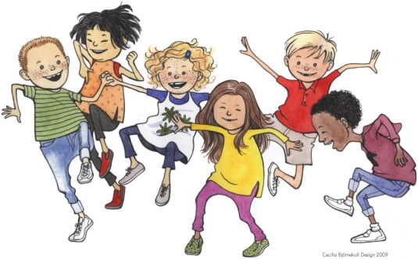](https://www.google.com/url?sa=i&rct=j&q=&esrc=s&source=images&cd=&ved=0ahUKEwin1uWiyejVAhXLa5oKHUNkC5EQjRwIBw&url=https://www.majema.se/blogg/category/ak-4-6/page/2/&psig=AFQjCNGzrVdGMzb4VNBUZKqPcw-OD61QmA&ust=1503413322741561)*Write as much as you can… Good luck!*

In your letter you can write about:

* your name and age
* where you were born
* where you live
* a little about your family
* your hobbies and interests
* what you do in your free time (spare time)
* your friends
* what you like
* what you don´t like
* what you think about school
* other things that you want to tell your teacher